Syeda Reeha Quasar

14114802719

4C7

Aim

Using concept of function overloading, write function for calculating area of triangle, circle and rectangle.

Experiment - 3

Object Oriented Programming Lab

# **EXPERIMENT – 3**

## **Aim:**

Using concept of function overloading, write function for calculating area of triangle, circle and rectangle.

## **Source Code:**

#include <iostream>

using namespace std;

int area(int l, int b){

    return l * b;

}

float area(float r){

    return 3.14 * r * r;

}

float area(float b, float h){

    return (b * h)/2;

}

int main(){

    int l, b;

    float r, ba, he;

    cout << "Enter length and breadth of rectangle" << endl;

    cin >> l >> b;

    cout << "Area of rectangle is: " << area(l, b) << endl;

    cout << "Enter radius for circle"<<endl;

    cin >> r;

    cout << "Area of circle is: " << area(r) << endl;

    cout << "Enter base and height of triangle" << endl;

    cin >> ba >> he;

    cout << "Area of triangle is: " << area(ba, he) << endl;

    return 0;

}

## **Output:**

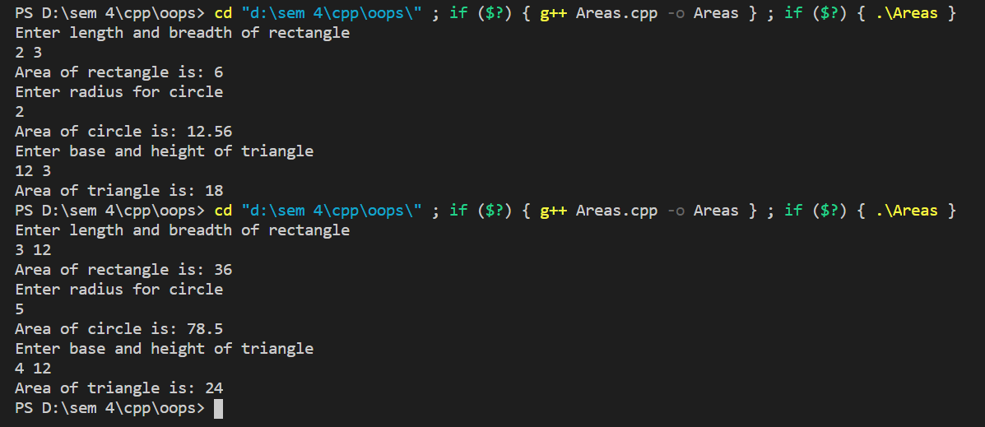

# **Viva Questions**

### **1. What do you mean by abstraction in C++?**

Ans.

Abstraction is the process of showing the essential details to the user and hiding the details which we don’t want to show to the user or hiding the details which are irrelevant to a particular user.

### **2. Is deconstructor overloading possible? If yes then explain and if no then why?**

Ans.

No destructor overloading is not possible. Destructors take no arguments, so there’s only one way to destroy an object. That’s the reason destructor overloading is not possible.

### **3. What do you mean by call by value and call by reference?**

Ans.

In call by value method, we pass a copy of the parameter is passed to the functions. For these copied values a new memory is assigned and changes made to these values do not reflect the variable in the main function.

In call by reference method, we pass the address of the variable and the address is used to access the actual argument used in the function call. So changes made in the parameter alter the passing argument.